# Connection

In this chapter the data flow from the automation at shopfloor level to the MES software is described. For that all machines need to be digitized and sensorized in order for a PLC to control the production steps and read the input and output data. With this done the data can be written into a server, which is then also accessed by the MES, where it can be processed, analyzed and displayed.

## Architecture of the connection between automation software and server

One of industries standard protocol that is widely used in automation is OPCUA, featuring flexible data transport across platforms and making machine data readable for other applications. Furthermore, it allows the user to easily write data into an OPCUA server.

When it comes to connecting the PLC to the OPCUA server there are three components that must be arranged and connected correctly. The TwinCAT environment controls the PLC and the input and output data of the PLC is written into the OPCUA server. The OPCUA expert can be utilized to test the connection and view the data. On the device that hosts the OPCUA server, TwinCAT XAR (runtime only) or TwinCAT XAE (runtime and engineering) has to be installed as well as the function TF6100 OPCUA. On each PC where a TwinCAT software product is used, the license TF6100 has to be activated. When setting up an OPCUA server authentication can be implemented by defining an username and password.

Figure x.x illustrates possible architectures of this system. Firstly, it is possible to run all components on one PC, which is obviously the easiest method. If it is wished to distribute the components on more than one PC, there are several ways to do so. For example, the TwinCAT environment with the PLC and the OPCUA server can be run on one PC, while the server data is accessed from another PC. Basically, every combination of the elements is possible, but it is notable, that a functional TwinCAT environment supporting the operation of the PLC is always on one device.

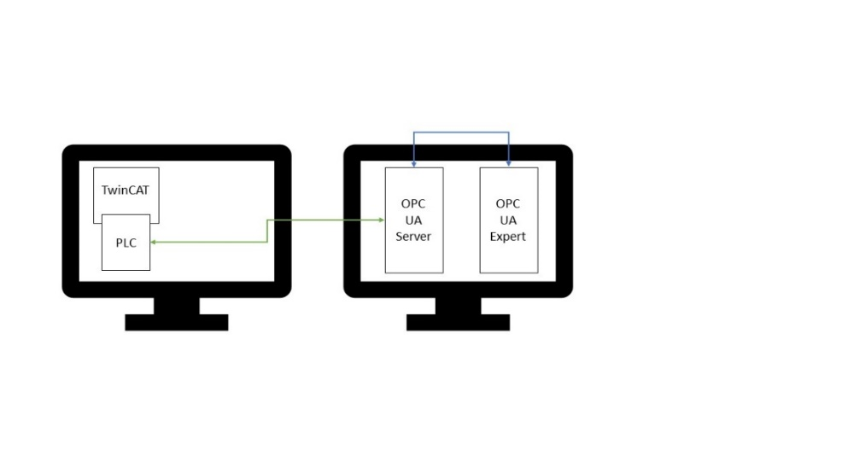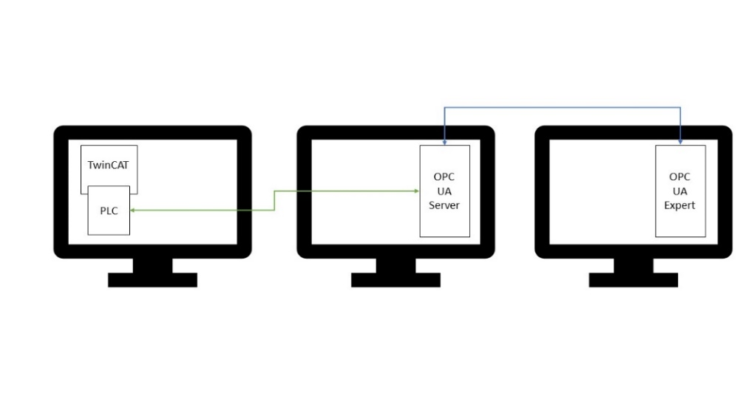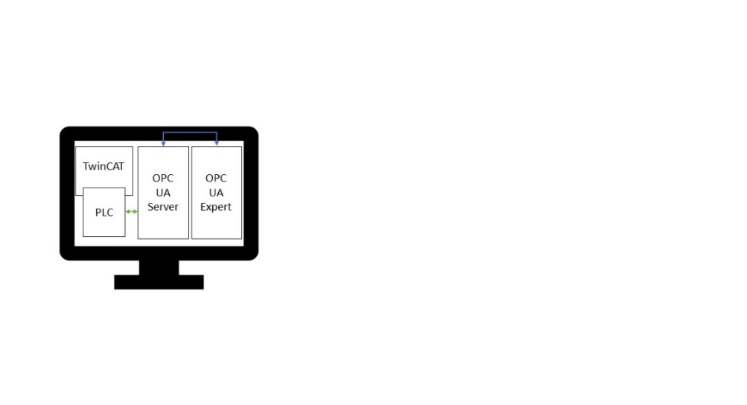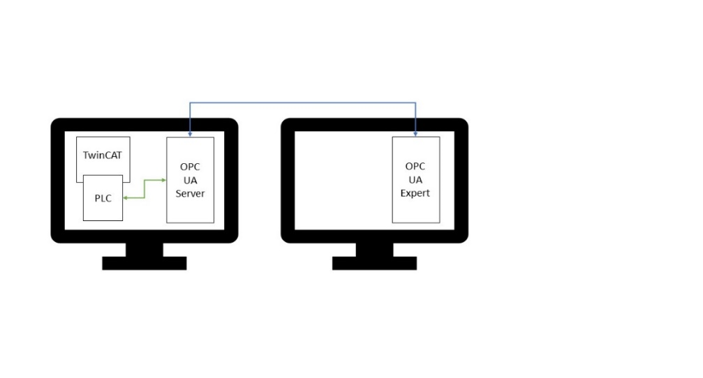

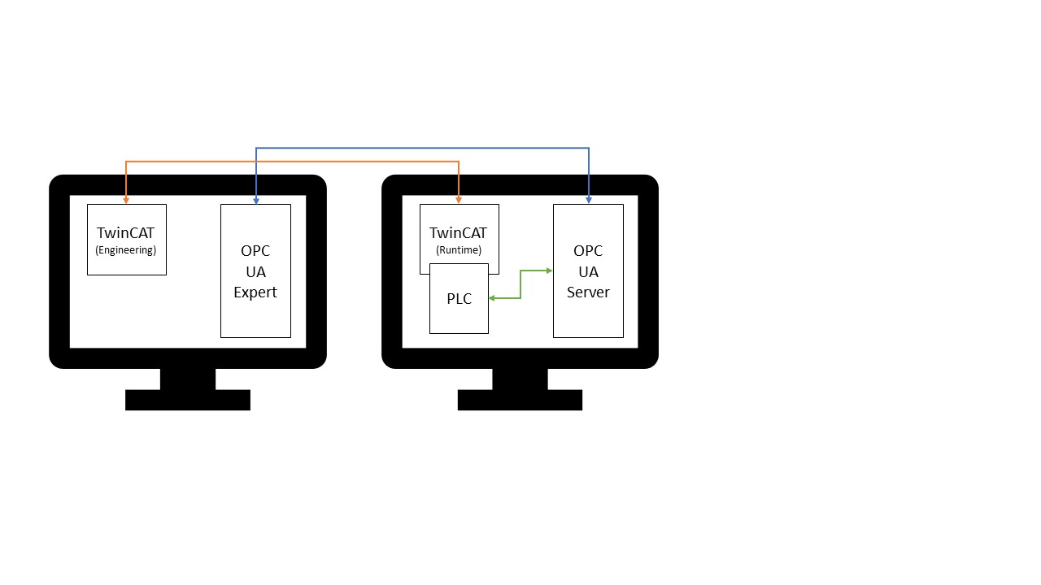Another way of connecting the components, when they are distributed on two PCs is shown in figure x.x. The left PC is the engineering computer, where the PLC program for the server is developed and the right PC is an industrial computer from Beckhoff. Here TwinCAT also has to be installed, but functions only as a runtime for the PLC. Furthermore the OPCUA server is hosted on the industrial PC. The access to the server data happens from the engineering computer with the OPCUA expert. In this architecture it is important that a valid OPCUA license is activated in each TwinCAT software product.

## Connecting to the MES

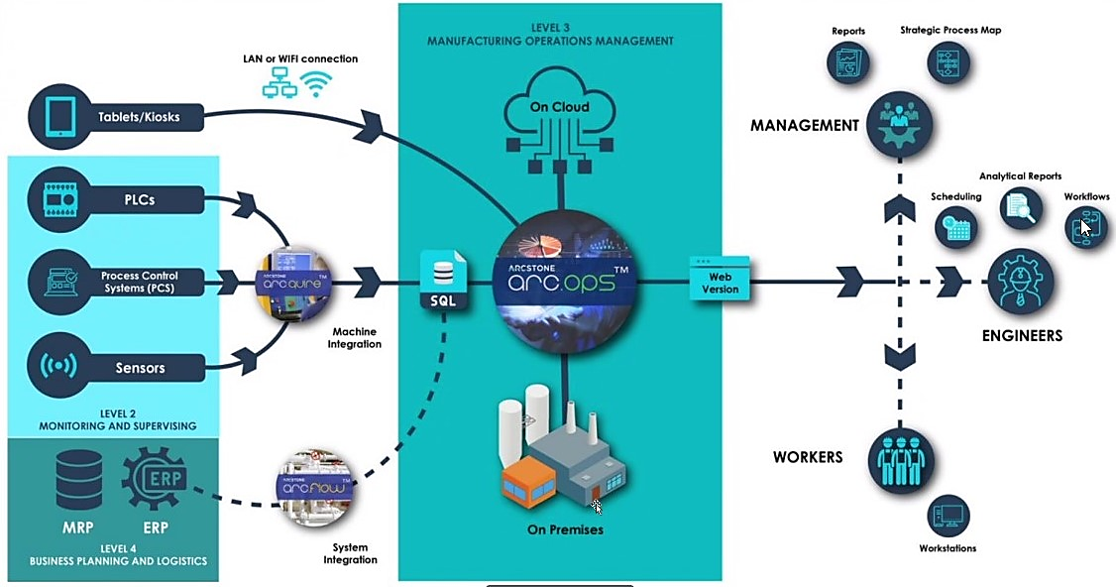Once the OPCUA server is set up, the data can be utilized in the MES. The used MES software is arc.ops from Arcstone. It features a specific tool for connecting to machines and pull the data named arc.quire, which features industries standard protocols, including OPCUA. A complete overview of Arcstones MES solutions is shown in Figure x.x.

When looked at Arcstones MES solutions in the context of the ISA 95 framework, arc.quire connects the automation level to the MES, arc.ops is the MES itself and arc.flow is the link between ERP and MES.

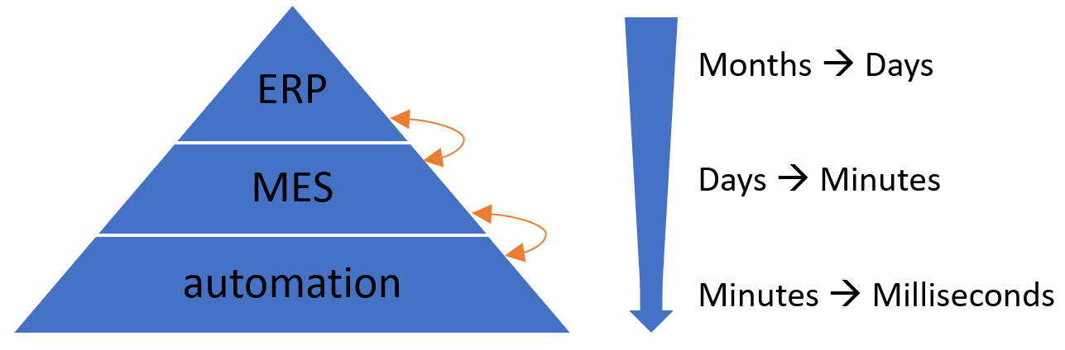

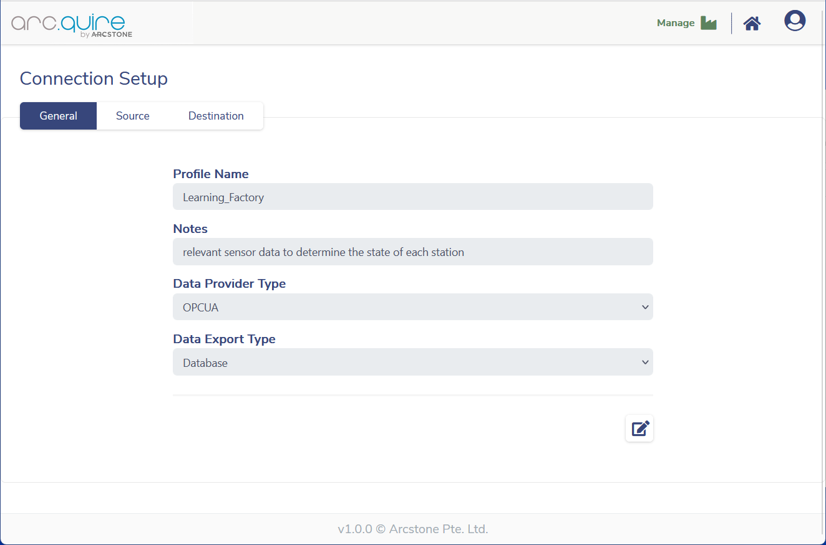A new arc.quire profile needs to be set up in order to pull the data to the MES. A meaningful name is chosen and a description of the profile can be added in the notes. Next, the data provider and export types have to be selected, whereby OPCUA is the provider and Database is the export for the learning.factory. Refer to Figure x.x for the example settings

In the following step the data source has to be defined as illustrated in Figure x.x. The OPCUA server URL has to be inserted as well as the publish interval and the authentication credentials if required. Afterwards, add the data that is wanted for the MES by giving each a meaningful name and inserting the corresponding node ID. If a test connection is run, the current data value is displayed in the right column.

Before the profile is ready to run, the data destination has to be specified, which is shown in Figure x.x. Most of the fields here are predefined and there is no need to change them. But the connection string has to be modified to match the username and password of the Arcstone server.

